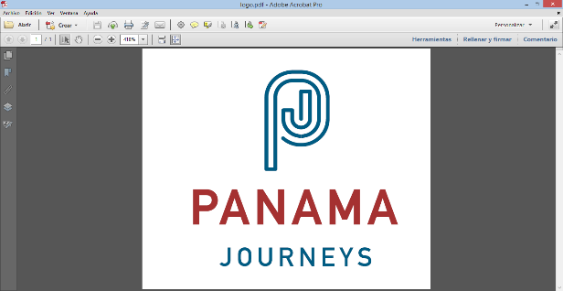

** “Fortaleza” Special Walk in Panama City at Dusk**

Under the catch phrase “We used to rob tourists before, now we offer them tours”, a group of young former gangsters from the fearsome criminal group known as Ciudad de Dios [City of God] tell tourists their story during a walk around the streets of the historic center which were declared red-light districts years before. These young men participate in a program of Esperanza Social Venture Club, a non-profit private organization that is part of Fundación Calicanto which has rehabilitated approximately forty criminals who belonged to the criminal groups named Hot boys, La Terraza and Ciudad de Dios [The Terrance and City of God] and it has helped them rejoin society. The walk starts at Plaza Herrera, in front of the luxurious American Trade Hotel which worked previously as a base for the criminal group Ciudad de Dios and from where gangsters used to keep an eye on tourists in order to rob them. The hotel’s structure was known as Grayskull, the imaginary castle of the 80’s TV show He-man. Next to the internal stairways, walls are decorated with graffiti images that used to cover the interior of the building at that time. During the walk, they will tell you episodes and anecdotes from those violent years while describing important buildings and going over forgotten footways that have not been restructured between Calle 9 [9th Street] and Calle 13 [13th Street]. The walk ends in Calle 11 [11th Street], rebaptized under the name of Callejón Fortaleza [Fortaleza Alley], a little dead-end street where the criminal group used to escape from the police, where nowadays it is a tourist reference with its local food places. Smiles, commitment and kindness of these young men will make you doubt about their dark past, still more, when they do state: “This is the real life and not the other one”, a phrase showing their enormous will to change.

**DURATION:** approximately 2 hours and a half.

**TIME:** to be agreed.

**GUIDE:** bilingual guide.